OpenCart Application

The objective of this e-commerce project is to develop a user-friendly and secure online shopping platform for customers to browse, purchase and track their orders.

The project will involve the development of a web-based application using OpenCart, an open-source e-commerce platform. **The application will include features such as user registration and login, product catalog, shopping cart, checkout, payments gateway integration, and order management.**

**Please note** - Requirment documentation contains details on user stories, test cases, and design mockups to each requirement to provide more clarity and context for the development team.

The project will aim to provide a seamless user experience and ensure the security of sensitive customer information. The target audience for this e-commerce platform will be customers looking to purchase a wide variety of products online.

| **Requirement** | **Description** | **Priority** | **Acceptance Criteria** |
| --- | --- | --- | --- |
| Login | Users should be able to create an account and log in to the system. | High | - User can access the login page from the homepage. <br> - User can enter their credentials and click the "login" button. <br> - User is redirected to their account dashboard upon successful login. |
| Registration | Users should be able to register for a new account. | High | - User can access the registration page from the homepage. <br> - User can enter their details (name, email, password, etc.) and click the "register" button. <br> - User is redirected to their account dashboard upon successful registration. |
| Add to Cart | Users should be able to add products to their cart. | High | - User can click the "Add to Cart" button on a product page. <br> - The product is added to the user's cart. <br> - User can view their cart and the products they have added. |
| Checkout | Users should be able to complete a purchase. | High | - User can click the "Checkout" button from their cart page. <br> - User can enter their shipping and billing information. <br> - User can choose a payment method and complete the transaction. |
| Payment Gateway | The system should integrate with a payment gateway. | High | - User can choose from a list of supported payment methods during checkout. <br> - User's payment information is securely transmitted to the payment gateway for processing. <br> - User receives a confirmation of their payment upon successful processing. |
| Orders | Users should be able to view their order history. | Medium | - User can access their order history from their account dashboard. <br> - User can view details about their past orders (date, products purchased, total cost, etc.). |

### Login

**User Stories**

As a new user, I want to be able to create a new account and login to the platform.

As an existing user, I want to be able to easily access my account by entering my login credentials.

**Design Mockups**

Login page design mockup

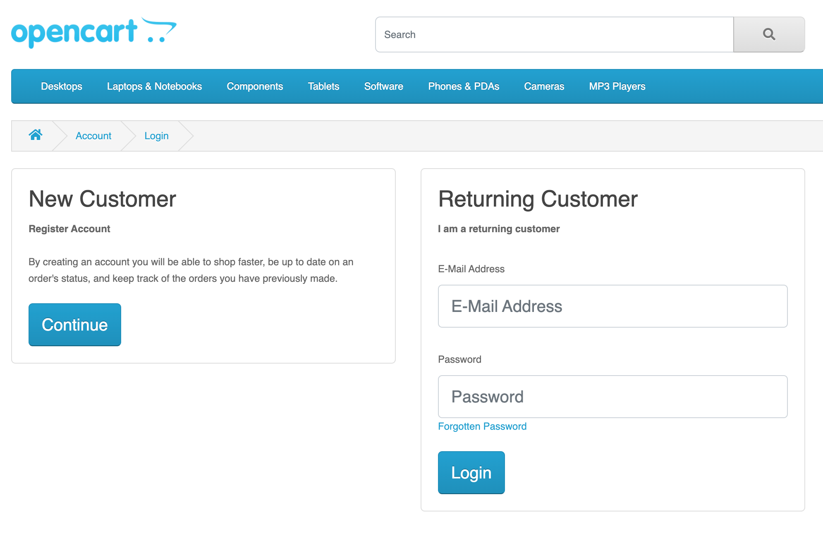

### Registration

User Stories

As a new user, I want to be able to easily create a new account and register for the platform.

As an existing user, I want to be able to update my account information and manage my preferences.

Test Cases

Design Mockups

Registration page design mockup

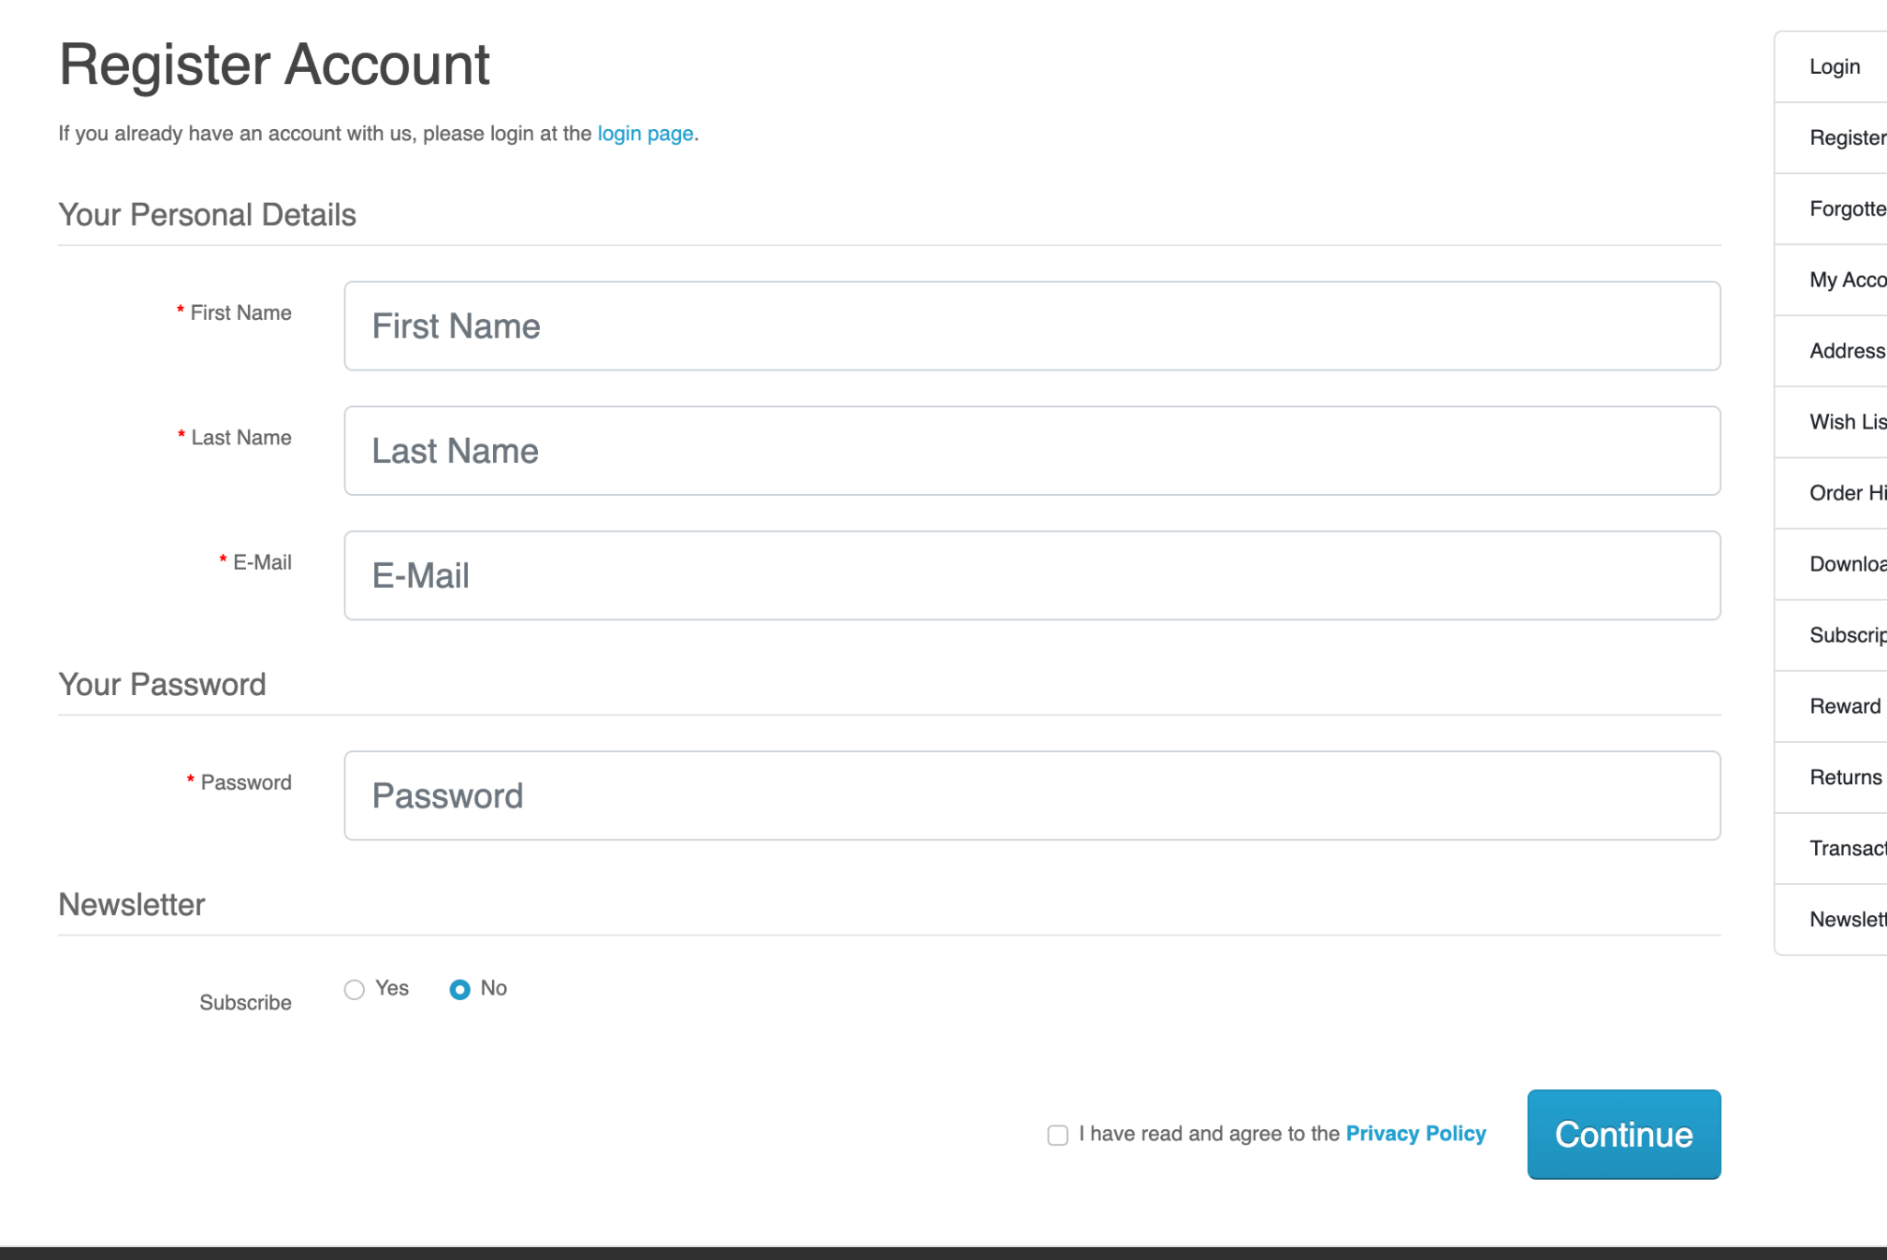

### Add to Cart

User Stories

As a customer, I want to be able to easily add products to my cart and view my cart.

As a customer, I want to be able to easily manage the contents of my cart.

Design Mockups

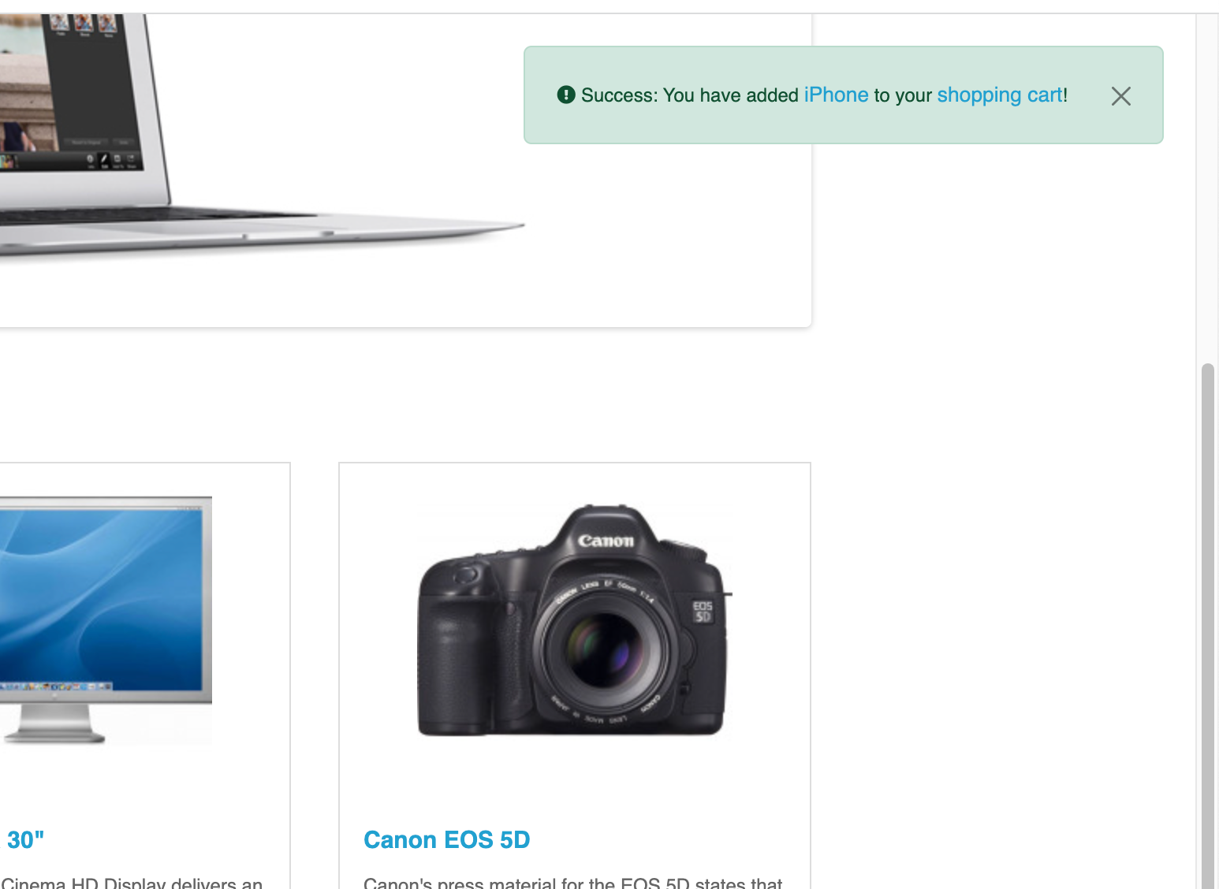

Product page design mockup with Add to Cart button

Cart page design mockup

### Checkout

User Stories

As a customer, I want to be able to easily complete my purchase and provide my payment information.

As a customer, I want to be able to view my order summary and confirm my purchase.

Test Cases

Verify that users can click the "Checkout" button from their cart page.

Verify that users can enter their shipping and billing information.

Verify that users can choose a payment method and complete the transaction.

Verify that users receive a confirmation of their payment upon successful processing.

Design Mockups

Checkout page design mockup

### Payment Gateway

User Stories

As a customer, I want to be able to choose from a variety of payment methods and securely enter my payment information.

As a platform, we want to ensure the security of customer payment information and provide a seamless payment experience.

### Orders

User Stories

As a customer, I want to be able to view my order history and track the status of my orders.

As a platform, we want to be able to manage and fulfill customer orders efficiently.

Link - <https://www.figma.com/file/TWe6MQGm3kRj51ux88ZJJl/Software-Testing---OpenCart-Project-to-Add-to-Resume-%231?node-id=1%3A155&t=JxhnvmUBrNBVBVrT-1>